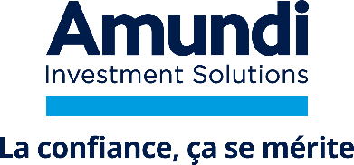
AMUNDI ETF DAX UCITS ETF DR
UCITS
SEMI-ANNUAL REPORT - SEPTEMBER 2025
Asset Management Company
Amundi Asset Management
Delegated fund accountant
Caceis Fund Administration
Custodian
CACEIS BANK
Auditors
DELOITTE & ASSOCIÉS

Contents
Pages
1
RefToc1,1,RefToc2,2,RefToc3,3,RefToc4,4,RefToc5,5,RefToc6,6,RefToc7,7,RefToc8,8,RefToc9,9RefToc1;1;RefToc2;2;RefToc3;3;RefToc4;4;RefToc5;5;RefToc6;6;RefToc7;7;RefToc8;8;RefToc9;9
Semi-Annual Report 3
Significant events during the financial period 5
Specific details 6
Certificate drafted by the Auditor relative to the asset composition for the Mutual Fund 7
Portfolio Listing 8
Informations about the Fund 14

Semi-Annual Report
Semi-Annual Report

The fund aims to achieve a performance identical to that of the Dax Net Return index. In order to obtain a performance close to the Dax Net Return index, the fund is managed according to an index methodology where the fund's composition replicates the composition of the index. Purchases/sales of shares or index futures are made during cash flows (subscriptions/redemptions, dividends, etc.).

For the period under review, the portfolio AMUNDI ETF DAX UCITS ETF DR performance is 7.37%. The benchmark performance is 7.20%.

Past performance is no guarantee of future performance.

Securities | Movements ("Accounting currency")
Securities | Acquisitions | Cessions
SAP SE | 74,139,589.95 | 47,767,787.78
SIEMENS AG-REG | 40,353,427.76 | 24,610,234.23
ALLIANZ SE-REG | 35,408,627.66 | 20,117,919.50
DEUTSCHE TELEKOM AG-REG | 29,819,257.70 | 18,073,013.42
AIRBUS SE | 24,135,683.85 | 15,857,340.72
RHEINMETALL AG | 20,919,260.65 | 11,918,858.50
MUENCHENER RUECKVERSICHERUNG AG | 18,657,910.80 | 11,066,794.19
SIEMENS ENERGY AG | 15,314,417.14 | 9,609,570.70
COMMERZBANK AG | 6,915,761.19 | 14,761,318.45
DEUTSCHE BANK AG | 11,963,205.85 | 8,607,275.59

Transparency of securities financing transactions and of reuse (SFTR) - Regulation SFTR - in accounting currency of the portfolio (EUR)

Over the course of the reporting period, the UCI was not involved in any transactions governed by the Securities Financing Transactions Regulation (SFTR).

Significant events during the financial period
Significant events during the financial period

None.

Specific details
Specific details

Voting rights

In accordance with the Fund’s Rules and the Fund Manager’s stated policy, the Fund Manager exercises the voting rights attached to the securities held by the Fund and decides on contributions in the form of securities, except where the securities are those of the Fund Manager itself or of any associate company as defined in Art L. 444-3 of the French Labour Code (Code du Travail).

Two documents, “Voting Policy” and “Report on the Exercise of Voting Rights”, prepared by the Fund Manager in compliance with the current regulations are available upon request.
This mutual fund (OPC) has not been selected as one of the funds which currently exercise voting rights.

|
Soft commissions

The Fund Manager has received no commissions on trade.

Soft commission

The Fund Manager has received no “soft” commissions.

Use of credit derivatives

The Fund has not used credit derivatives during the period under consideration.

|
Group funds

In order to obtain information on the financial instruments held in the portfolio that are issued by the Management Company or by its affiliates, please refer to the sections:
• Additional information,
• Group financial instruments held in the portfolio in the annual financial statements for the year ended, attached hereto.

|
Calculating overall risk

• Overall risk calculation method: the mutual fund uses the commitment calculation method to calculate the mutual fund's overall exposure to financial contracts.

Certificate drafted by the Auditor relative to the asset composition for the Mutual Fund
Certificate drafted by the Auditor relative to the asset composition for the Mutual Fund

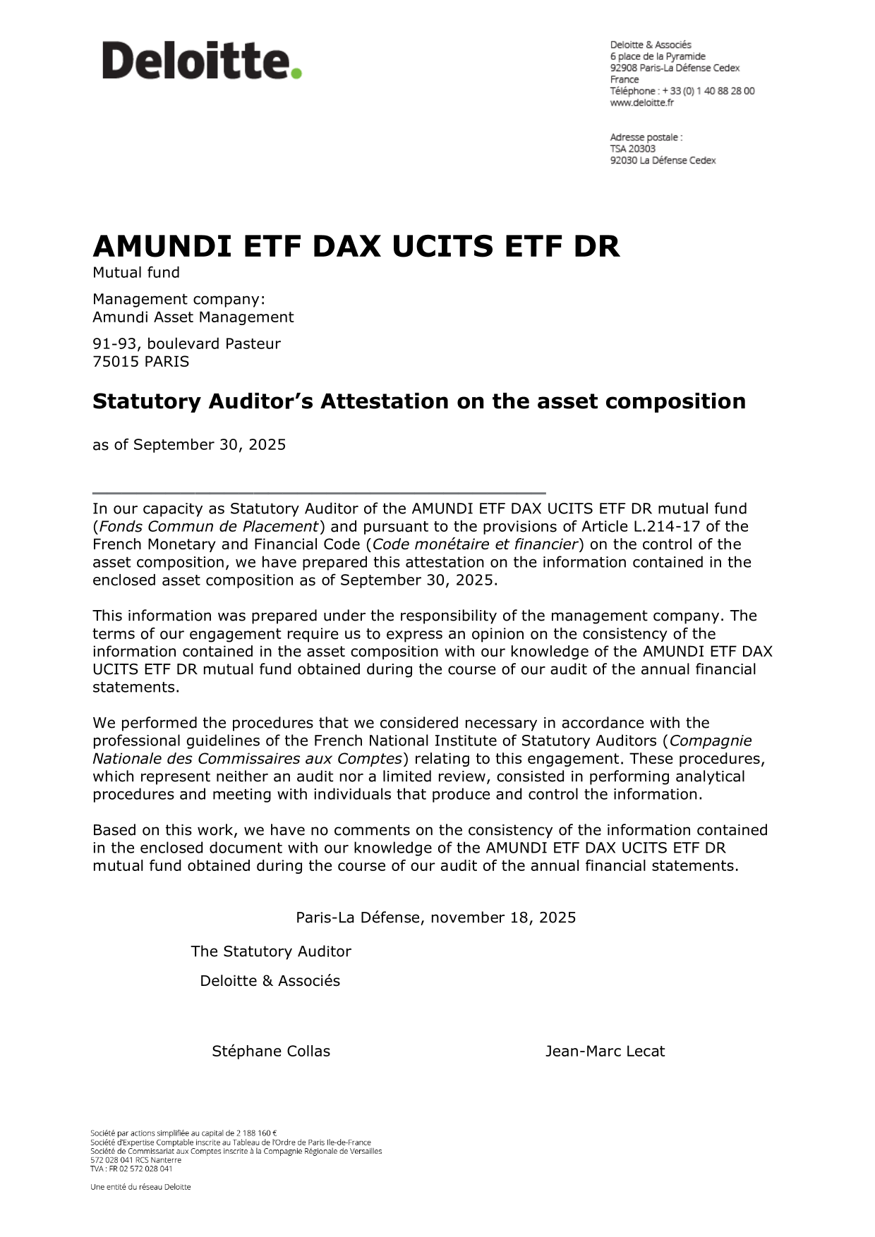

Portfolio listing of assets and liabilities
Portfolio Listing

Portfolio listing of balance sheet items

Instruments by business sector (*) | Currency | Quantity or  Nominal | Present value | % Net  Asset
EQUITIES AND SIMILAR SECURITIES |  |  | 1,439,500,465.73 | 99.73
Equities and similar securities traded on regulated or similar market |  |  | 1,439,500,465.73 | 99.73
Aerospace & Defense |  |  | 118,273,255.62 | 8.19
AIRBUS SE | EUR | 507,357 | 100,131,977.52 | 6.93
MTU AERO ENGINES AG | EUR | 46,409 | 18,141,278.10 | 1.26
Automotives |  |  | 91,283,960.64 | 6.32
BAYERISCHE MOTOREN WERKE AG | EUR | 241,041 | 20,594,543.04 | 1.43
DAIMLER TRUCK HOLDING AG | EUR | 477,869 | 16,734,972.38 | 1.16
MERCEDES BENZ GROUP AG REGISTERED SHARES | EUR | 620,686 | 33,188,080.42 | 2.29
PORSCHE AUTOMOBIL HLDG-PRF | EUR | 132,028 | 4,416,336.60 | 0.31
VOLKSWAGEN AG-PREF | EUR | 177,795 | 16,350,028.20 | 1.13
Automotives Components |  |  | 5,226,062.76 | 0.36
CONTINENTAL AG | EUR | 93,123 | 5,226,062.76 | 0.36
Chemicals |  |  | 46,484,304.33 | 3.22
BASF SE | EUR | 769,553 | 32,621,351.67 | 2.26
BRENNTAG AG NAMEN | EUR | 105,819 | 5,386,187.10 | 0.37
SYMRISE AG | EUR | 114,489 | 8,476,765.56 | 0.59
Commercial Banks |  |  | 69,415,563.78 | 4.81
COMMERZBANK AG | EUR | 595,347 | 19,104,685.23 | 1.32
DEUTSCHE BANK AG | EUR | 1,679,829 | 50,310,878.55 | 3.49
Construction Materials |  |  | 21,100,190.25 | 1.46
HEIDELBERG MATERIALS AG | EUR | 110,155 | 21,100,190.25 | 1.46
Diversified Financial Services |  |  | 37,033,631.70 | 2.57
DEUTSCHE BOERSE AG | EUR | 162,357 | 37,033,631.70 | 2.57
Diversified Telecommunication Services |  |  | 88,020,691.50 | 6.10
DEUTSCHE TELEKOM AG-REG | EUR | 3,034,150 | 88,020,691.50 | 6.10
Health Care Equipment & Supplies |  |  | 12,926,235.66 | 0.90
SIEMENS HEALTHINEERS AG | EUR | 280,883 | 12,926,235.66 | 0.90
Household Products |  |  | 9,290,163.60 | 0.64
HENKEL AG AND CO.KGAA NON VTG PRF | EUR | 135,228 | 9,290,163.60 | 0.64
Independent Power & Renewable Electricity Producers |  |  | 22,051,253.56 | 1.53
RWE AG | EUR | 583,058 | 22,051,253.56 | 1.53
Industrial Conglomerates |  |  | 227,325,571.20 | 15.75
RHEINMETALL AG | EUR | 39,664 | 78,713,208.00 | 5.45
SIEMENS AG-REG | EUR | 648,396 | 148,612,363.20 | 10.30

Portfolio listing of balance sheet items

Instruments by business sector (*) | Currency | Quantity or  Nominal | Present value | % Net  Asset
Insurance |  |  | 193,494,041.00 | 13.41
ALLIANZ SE-REG | EUR | 332,962 | 119,000,618.80 | 8.25
HANNOVER RUECK SE | EUR | 51,762 | 13,282,129.20 | 0.92
MUENCHENER RUECKVERSICHERUNG AG | EUR | 112,645 | 61,211,293.00 | 4.24
Life Sciences Tools & Services |  |  | 7,075,087.64 | 0.49
QIAGEN N.V. | EUR | 187,693 | 7,075,087.64 | 0.49
Machinery |  |  | 68,879,503.26 | 4.77
GEA GROUP AG | EUR | 125,632 | 7,895,971.20 | 0.55
SIEMENS ENERGY AG | EUR | 613,393 | 60,983,532.06 | 4.22
Mails, Air Freight & Logistics |  |  | 30,191,248.22 | 2.09
DEUTSCHE POST AG NAMEN | EUR | 795,763 | 30,191,248.22 | 2.09
Media and interactive services |  |  | 6,893,502.20 | 0.48
SCOUT24 SE | EUR | 64,667 | 6,893,502.20 | 0.48
Medical Cares and other services |  |  | 24,885,948.20 | 1.72
FRESENIUS MEDICAL | EUR | 180,760 | 8,072,741.60 | 0.56
FRESENIUS SE & CO KGAA | EUR | 354,709 | 16,813,206.60 | 1.16
Personal Products |  |  | 6,886,286.00 | 0.48
BEIERSDORF AG | EUR | 77,374 | 6,886,286.00 | 0.48
Pharmaceuticals |  |  | 36,109,428.07 | 2.50
BAYER | EUR | 847,069 | 23,912,757.87 | 1.65
MERCK KGAA | EUR | 111,436 | 12,196,670.20 | 0.85
Real Estate Management & Development |  |  | 16,354,375.20 | 1.13
VONOVIA SE | EUR | 615,984 | 16,354,375.20 | 1.13
Semiconductors & Semiconductor Equipment |  |  | 37,383,067.20 | 2.59
INFINEON TECHNOLOGIES | EUR | 1,125,996 | 37,383,067.20 | 2.59
Software |  |  | 205,495,262.60 | 14.24
SAP SE | EUR | 878,326 | 200,170,495.40 | 13.87
ZALANDO SE | EUR | 204,720 | 5,324,767.20 | 0.37
Textiles, Apparel & Luxury Goods |  |  | 26,420,058.60 | 1.83
ADIDAS AG | EUR | 147,269 | 26,420,058.60 | 1.83
Utilities sector |  |  | 31,001,772.94 | 2.15
E.ON SE | EUR | 1,935,796 | 31,001,772.94 | 2.15
INDEMNITIES ON LOANED SECURITIES |  |  | 223.61 | 0.00
Total |  |  | 1,439,500,689.34 | 99.73

(*) The business sector is the main activity of the issuer of the financial instrument and is derived from internationally recognised reliable sources (GICS and NACE mainly).

Portfolio listing of foreign exchange forward transactions

Type of transaction | Present value presented in the balance sheet |  | Exposure amount (*)
Type of transaction | Asset | Liability | Currency receivables (+) |  | Currency payables (-)
Type of transaction | Asset | Liability | Currency | Amount (*) | Currency | Amount (*)
Total

(*) Amount determined in accordance with the provisions of the exposure presentation regulation expressed in the accounting currency.

Portfolio listing of forward financial instruments

Portfolio listing of forward financial instruments-Equities

Type of commitment | Quantity or  Nominal | Present value presented in the balance sheet |  | Exposure amount (*)
Type of commitment | Quantity or  Nominal | Asset | Liability | +/-
1. Futures
DAX 30 IND FU 1225 | 6.00 | 37,025.00 |  | 3,601,650.00
MICRO DAX 1225 | 3.00 | 1,083.00 |  | 72,033.00
Sub-total 1. |  | 38,108.00 |  | 3,673,683.00
2. Options
Sub-total 2.
3. Swaps
Sub-total 3.
4. Other instruments
Sub-total 4.
Total |  | 38,108.00 |  | 3,673,683.00

(*) Amount determined according to the provisions of the regulations relating to exposures presentation.

|
Portfolio listing of forward financial instruments-Interest rate

Type of commitment | Quantity or  Nominal | Present value presented in the balance sheet |  | Exposure amount (*)
Type of commitment | Quantity or  Nominal | Asset | Liability | +/-
1. Futures
Sub-total 1.
2. Options
Sub-total 2.
3. Swaps
Sub-total 3.
4. Other instruments
Sub-total 4.
Total

(*) Amount determined according to the provisions of the regulations relating to exposures presentation.

Portfolio listing of forward financial instruments-Change

Type of commitment | Quantity or  Nominal | Present value presented in the balance sheet |  | Exposure amount (*)
Type of commitment | Quantity or  Nominal | Asset | Liability | +/-
1. Futures
Sub-total 1.
2. Options
Sub-total 2.
3. Swaps
Sub-total 3.
4. Other instruments
Sub-total 4.
Total

(*) Amount determined according to the provisions of the regulations relating to exposures presentation.

|
Portfolio listing of forward financial instruments-Credit risk

Type of commitment | Quantity or  Nominal | Present value presented in the balance sheet |  | Exposure amount (*)
Type of commitment | Quantity or  Nominal | Asset | Liability | +/-
1. Futures
Sub-total 1.
2. Options
Sub-total 2.
3. Swaps
Sub-total 3.
4. Other instruments
Sub-total 4.
Total

(*) Amount determined according to the provisions of the regulations relating to exposures presentation.

Portfolio listing of forward financial instruments-Other exposures

Type of commitment | Quantity or  Nominal | Present value presented in the balance sheet |  | Exposure amount (*)
Type of commitment | Quantity or  Nominal | Asset | Liability | +/-
1. Futures
Sub-total 1.
2. Options
Sub-total 2.
3. Swaps
Sub-total 3.
4. Other instruments
Sub-total 4.
Total

(*) Amount determined according to the provisions of the regulations relating to exposures presentation.

|
Portfolio listing of forward financial instruments or foreign exchange forward transactions used to hedge a unit category

The UCI under review is not covered by this section.

|
Portfolio listing summary

 | Present value presented in the balance sheet
Total inventory of eligible assets and liabilities (excl. forward financial instruments) | 1,439,500,689.34
Inventory of FDI (except FDI used for hedging of issued shares):
Total forex futures transactions
Total forward financial instruments - equities | 38,108.00
Total forward financial instruments - interest rates
Total forward financial instruments - forex
Total forward financial instruments - credit
Total forward financial instruments - other exposures
Inventory of forward financial instruments used to hedge issued units
Other assets (+) | 4,246,301.80
Other liabilities (-) | -446,721.42
Financing liabilities (-)
Total = Net Assets | 1,443,338,377.72

Unit name | Unit currency | Number of units | Net asset value
Unit AMUNDI ETF DAX UCITS ETF DR | EUR | 3,404,951 | 423.8940

Informations about the Fund
Informations about the Fund

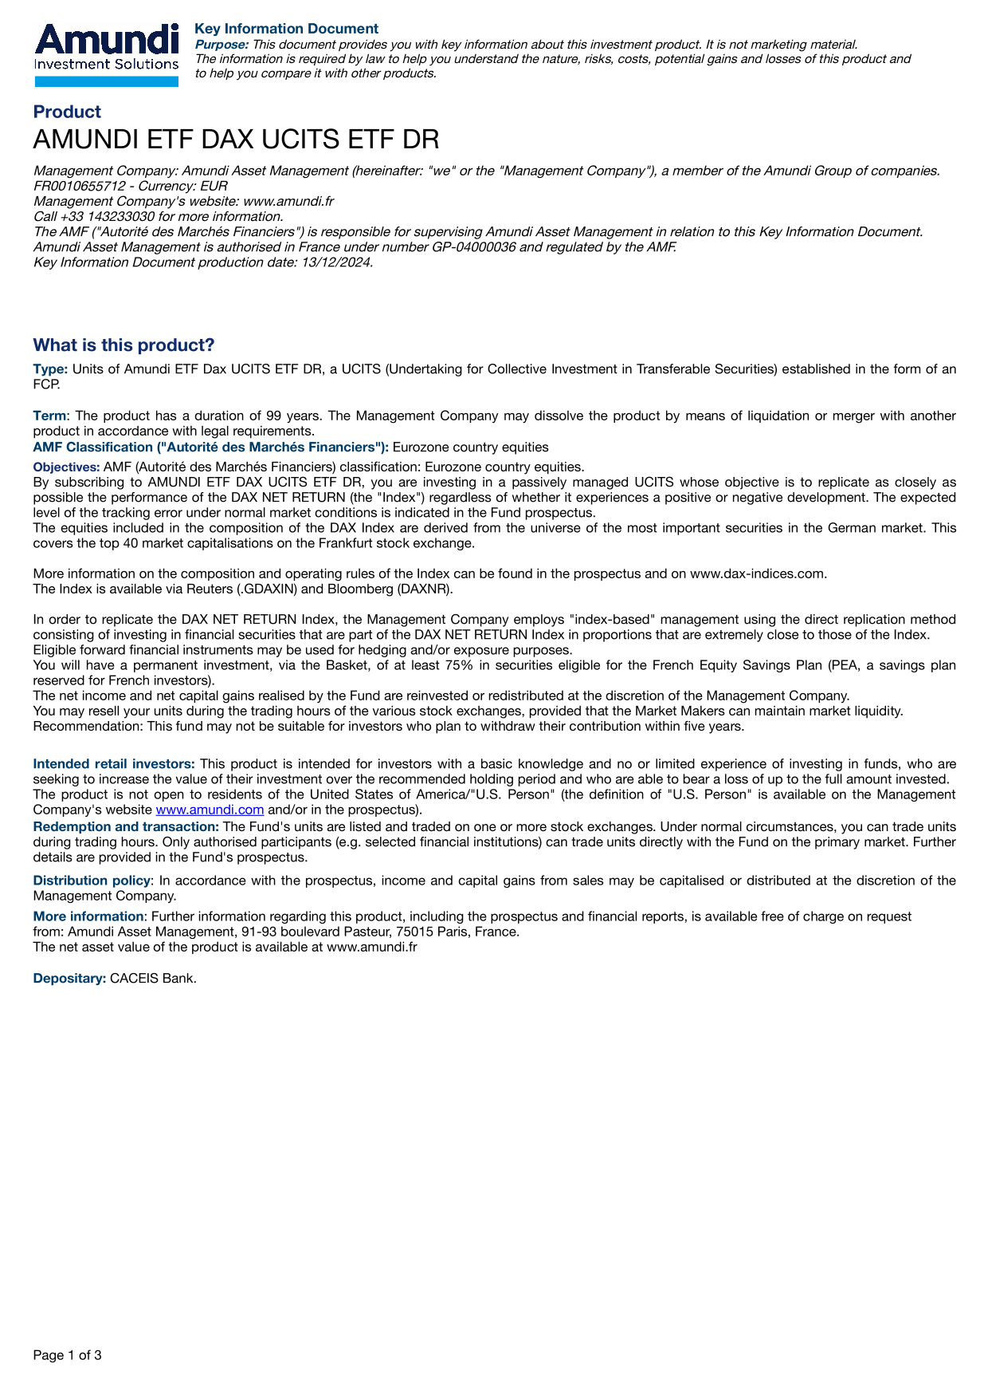
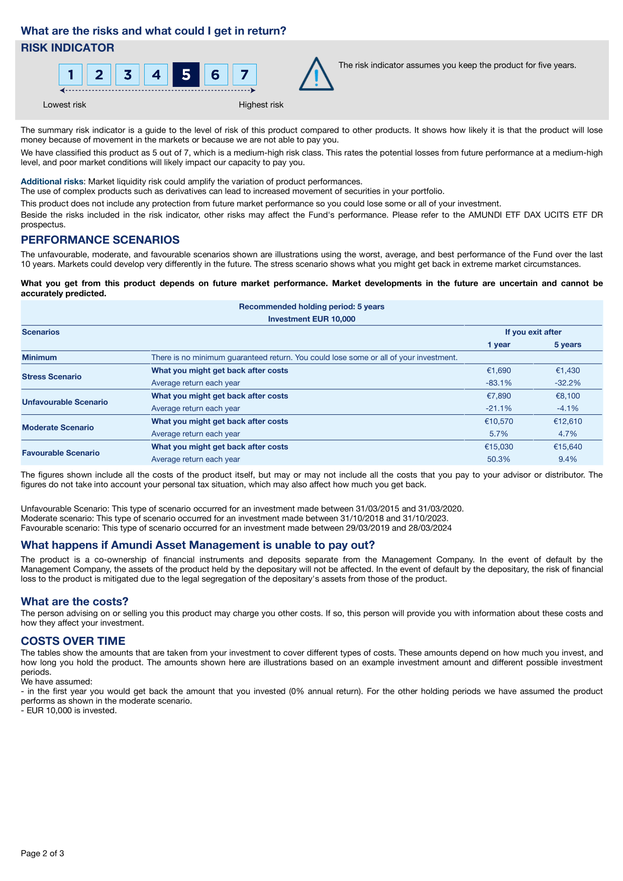
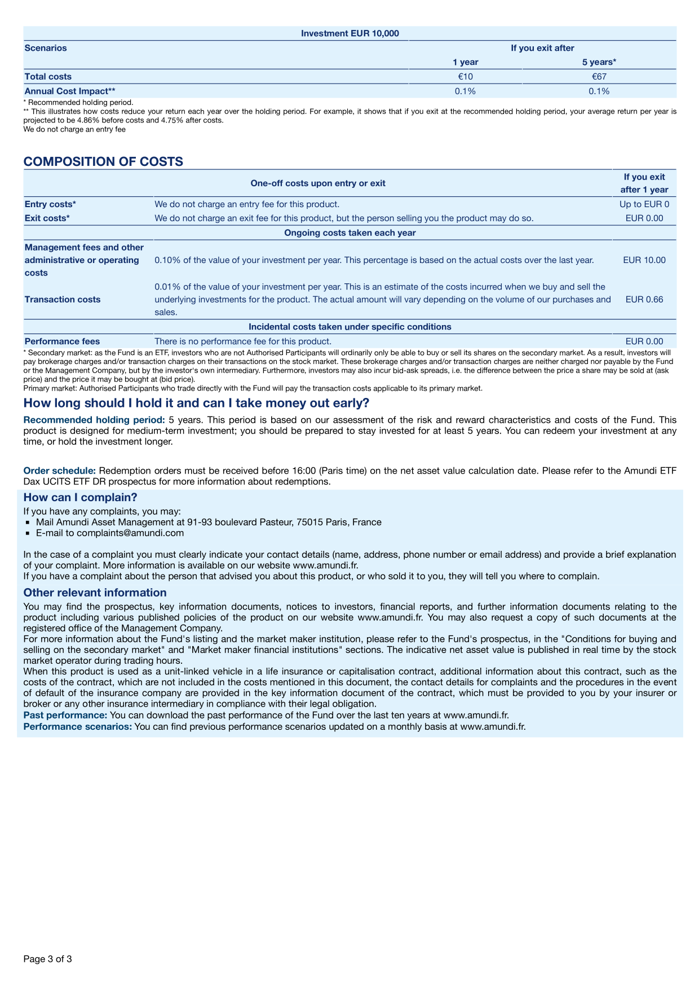

LEGAL NOTICE

Amundi Asset Management
Registered office : 91-93 boulevard Pasteur - 75015 Paris - France.
Postal address : 91-93 boulevard Pasteur CS21564 75730 Paris Cedex 15 - France.
Tel. +33 (0)1 76 33 30 30- amundi.com
French “société par actions simplifiée”-SAS. 1 143 615 555 € capital amount.
Licensed by the French Market Regulator (AMF) as a portfolio management company reg N° GP 04 000 036.
Siren : 437 574 452 RCS Paris - Siret : 43757445200029 - Code APE : 6630 Z - N° Identification
TVA : FR58437574452.

